<https://dev.mysql.com/downloads/installer/>

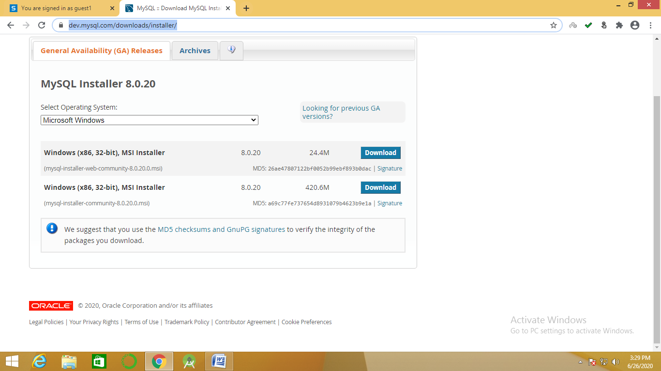

select windows (x86, 32 bit)MIS Installer 8.0.20 24.4 M click on download tab

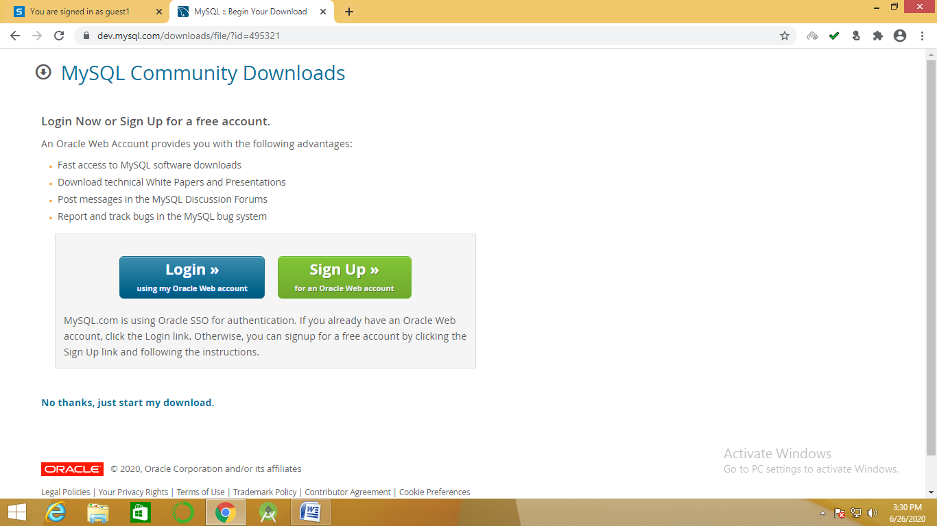

click on NO Thanks, Just Start my Download

Download mysql.msi file

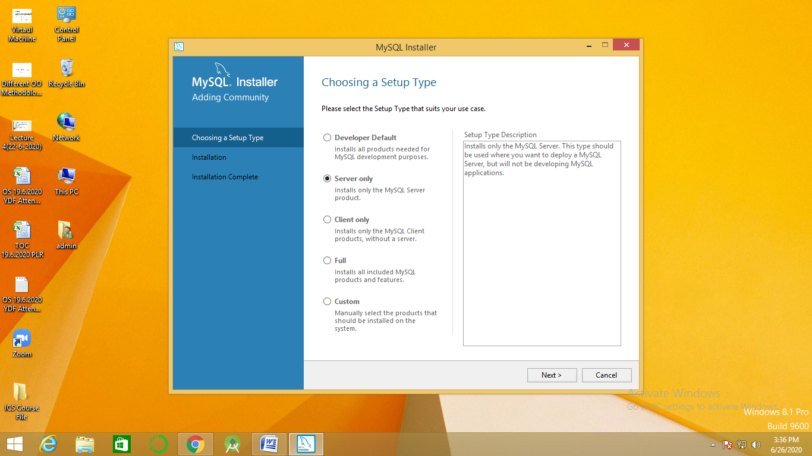

click on server only- click on Next- click on next -

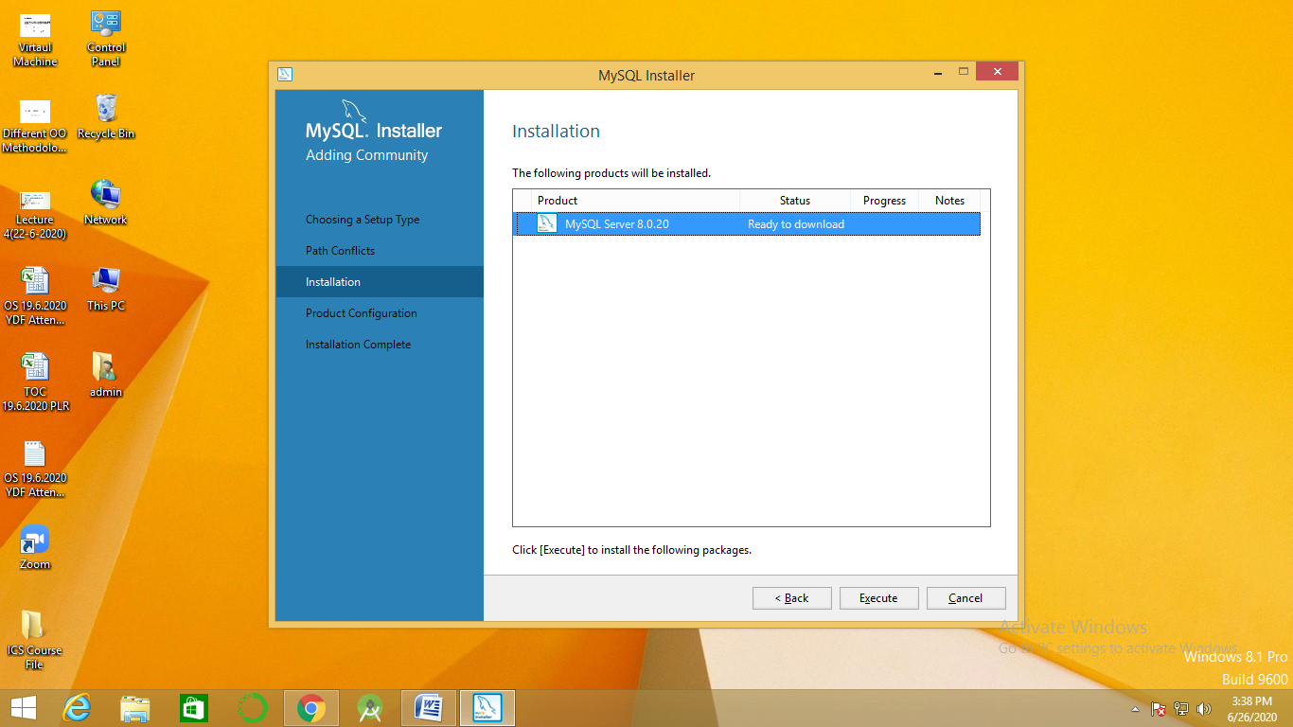

click on Execute

click on next

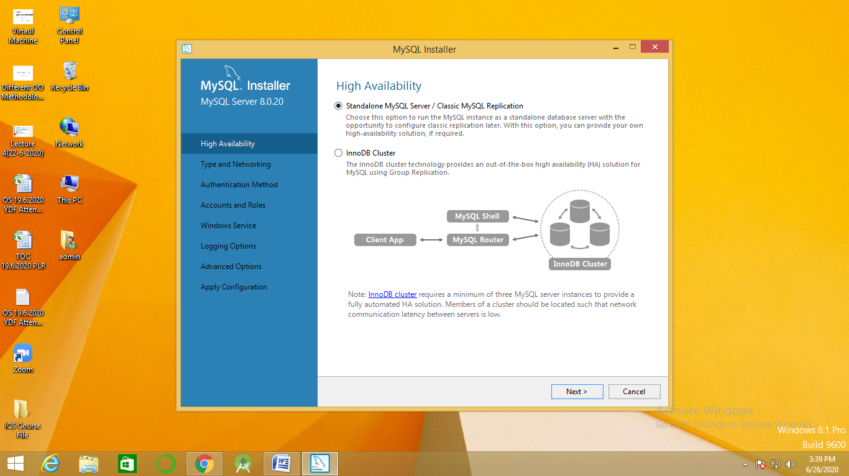click on next

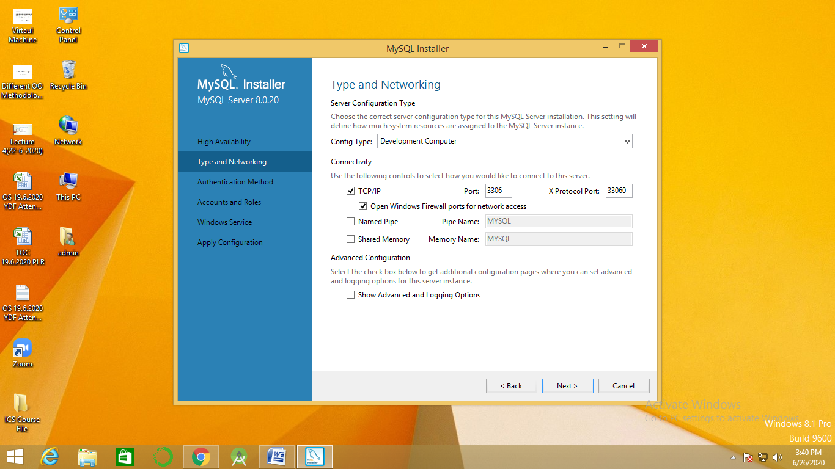

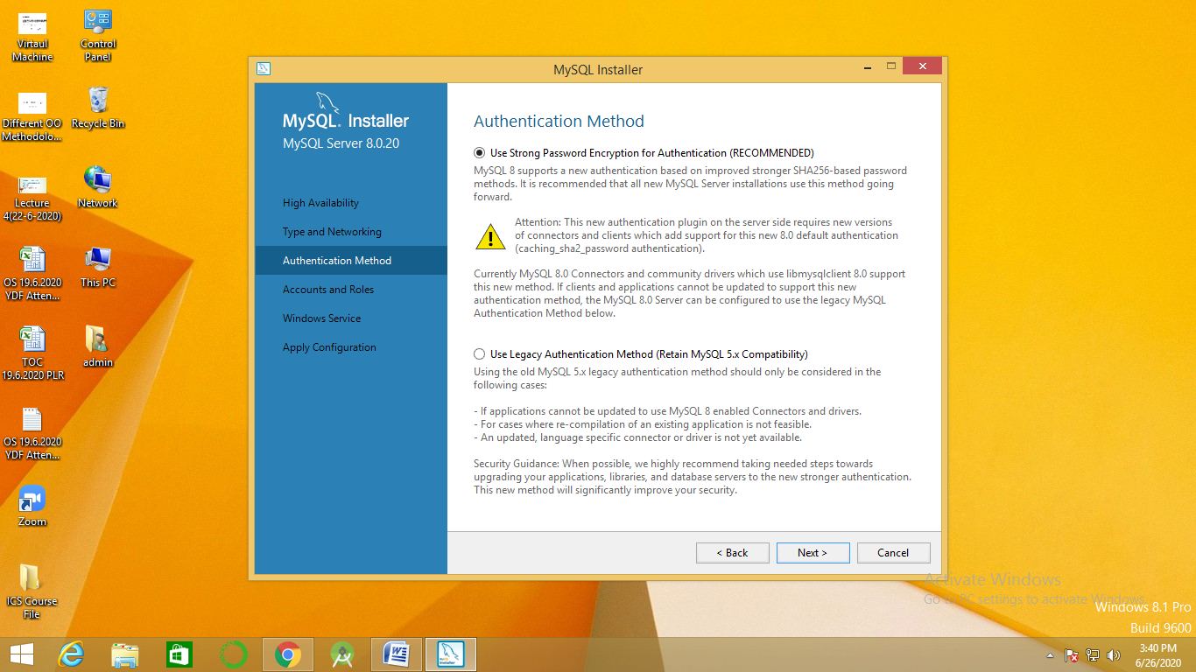

click on next

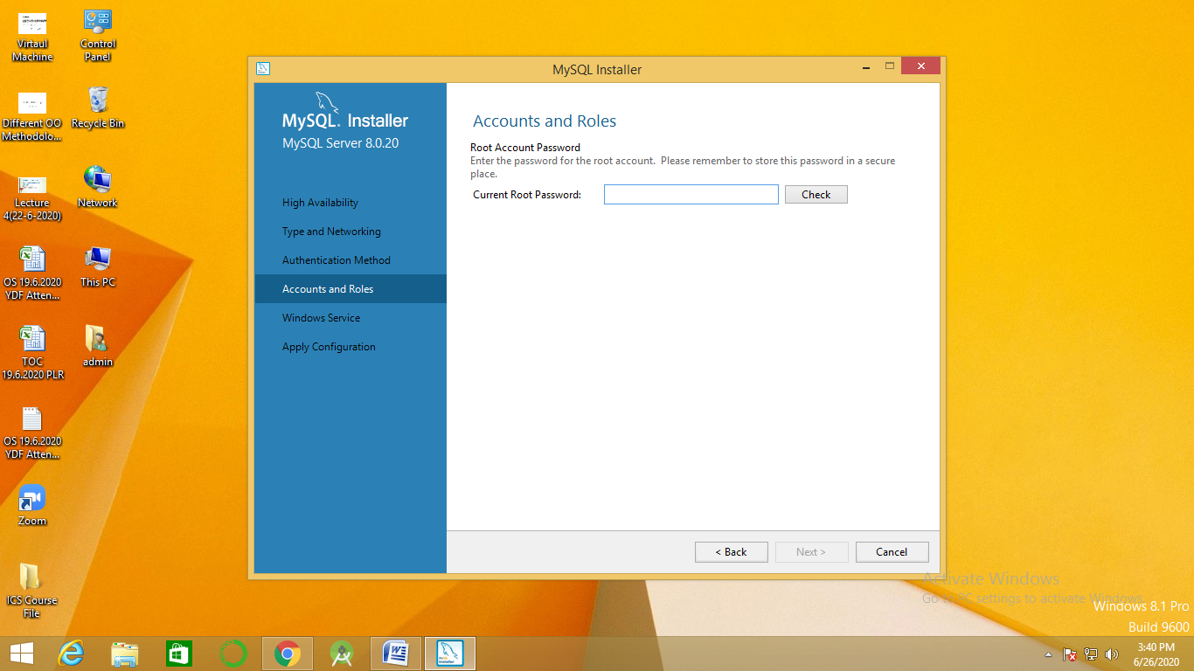

root password: root

re enter password: root